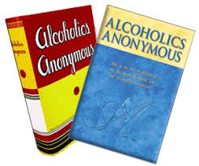 | The Big Book of Chesapeake Group  Agape Ministries, 4227 Bainbridge Ave 23324 | 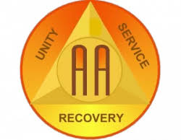

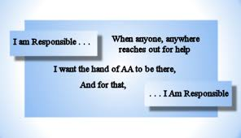
Your invited to celebrate our 4-year Anniversary!!
DINNER & SPEAKER
Come celebrate with us in fellowship!!!
SEPTEMBER 9th at 4:30pm
Please bring a side dish if you can – A main dish and drinks will be provided
Dinner starts at 4:30 pm – Speaker at 5:30-6:30pm
Agape Ministries, 4227 Bainbridge Ave 23324
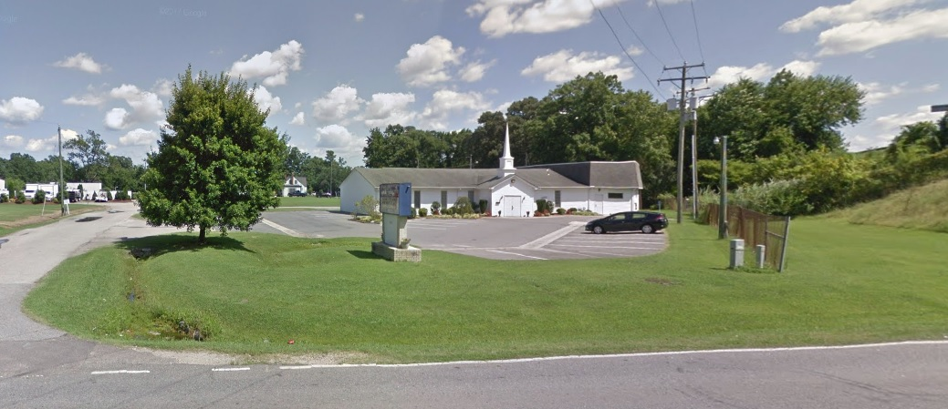 | 